Daily Report uploading to AWS server SOP

URL - https://s3.console.aws.amazon.com/
Credential - Account id: 702610019518
User id: mayuresh.hedaoo@bajajelectricals.com
Password: plm@2023
Please Note: This is the daily activity for Bajaj Electricals for their Power BI dashboards.
Where they need the reports upload from Each week Monday to Friday.

- Open the AWS client server go to Bucket S3 as shown in picture.

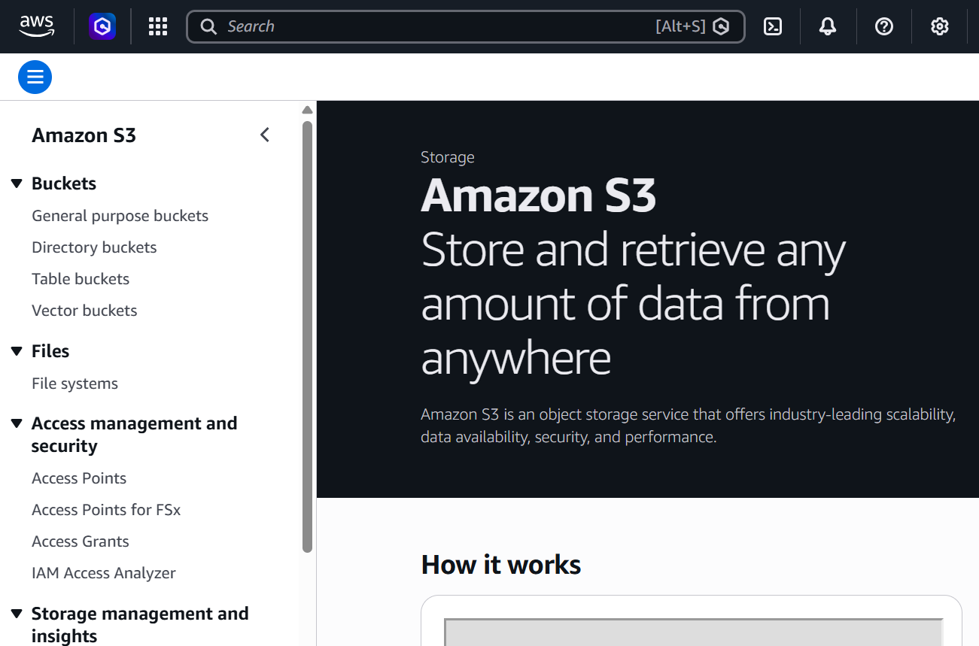

- Search the bucket by the name belpbi => PLM folder.

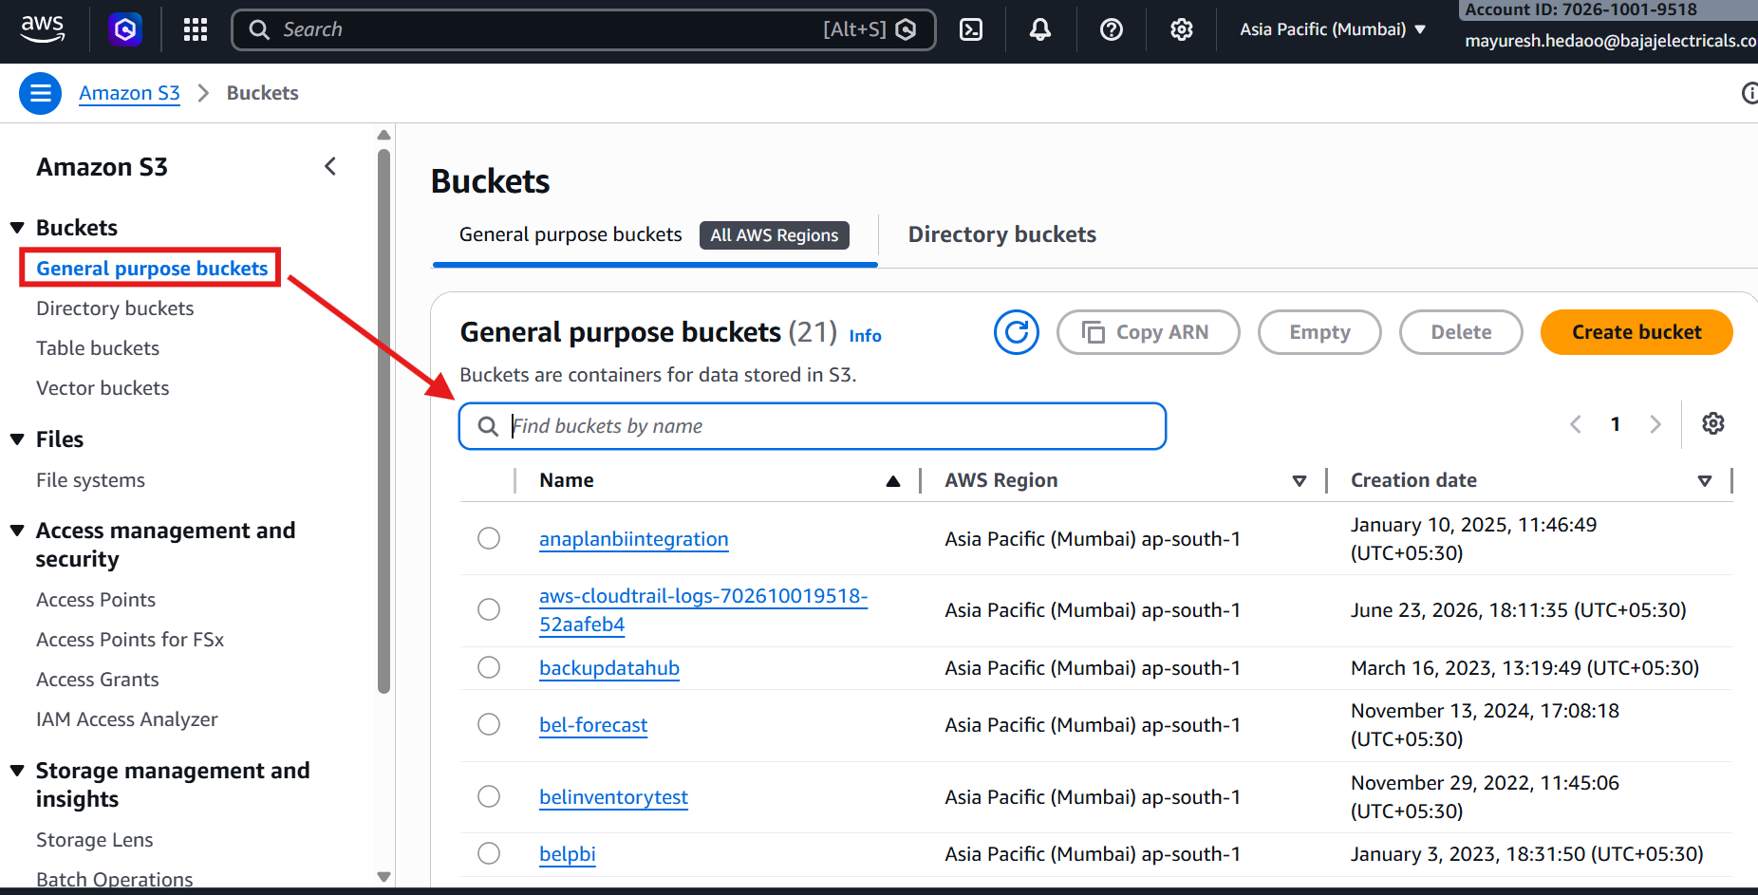

- Follow this folder path as shown in picture. - Bucket s3://belpbi/PLM/

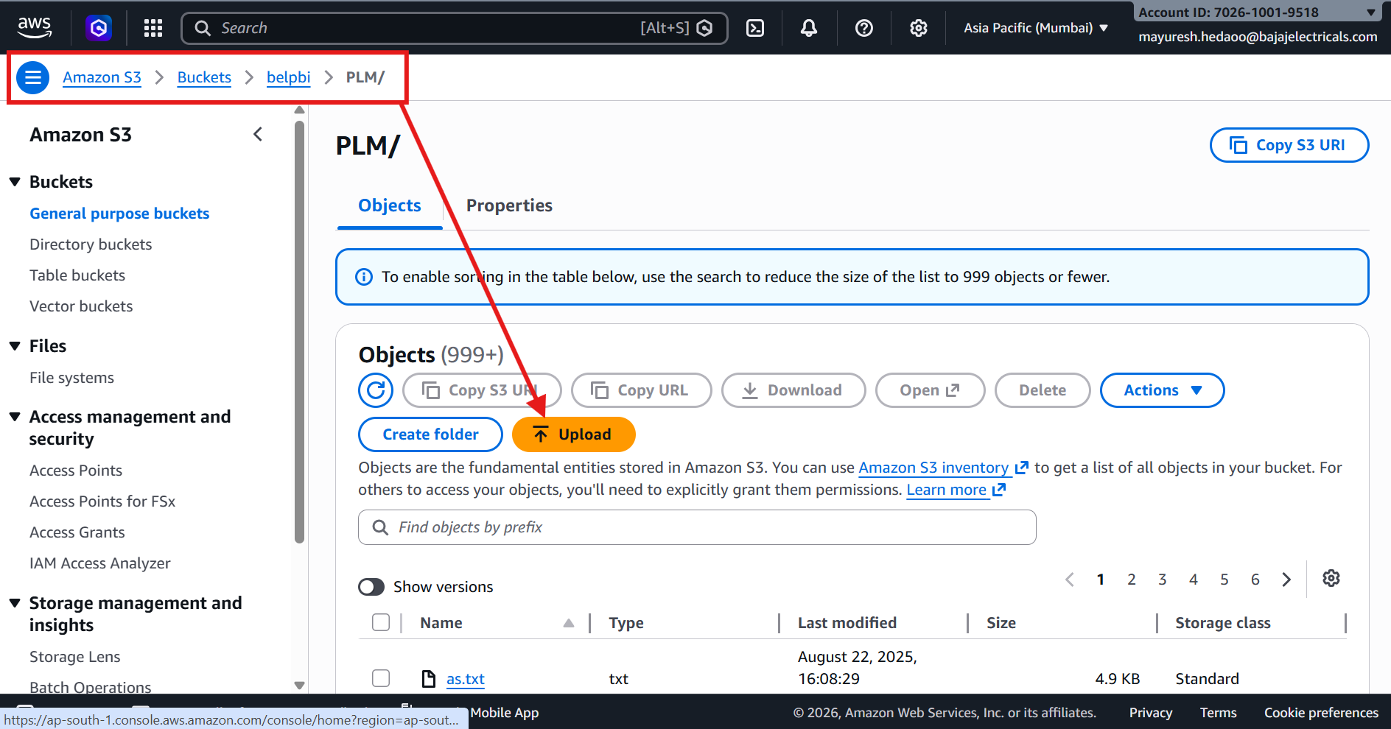

- Upload the files from local system.

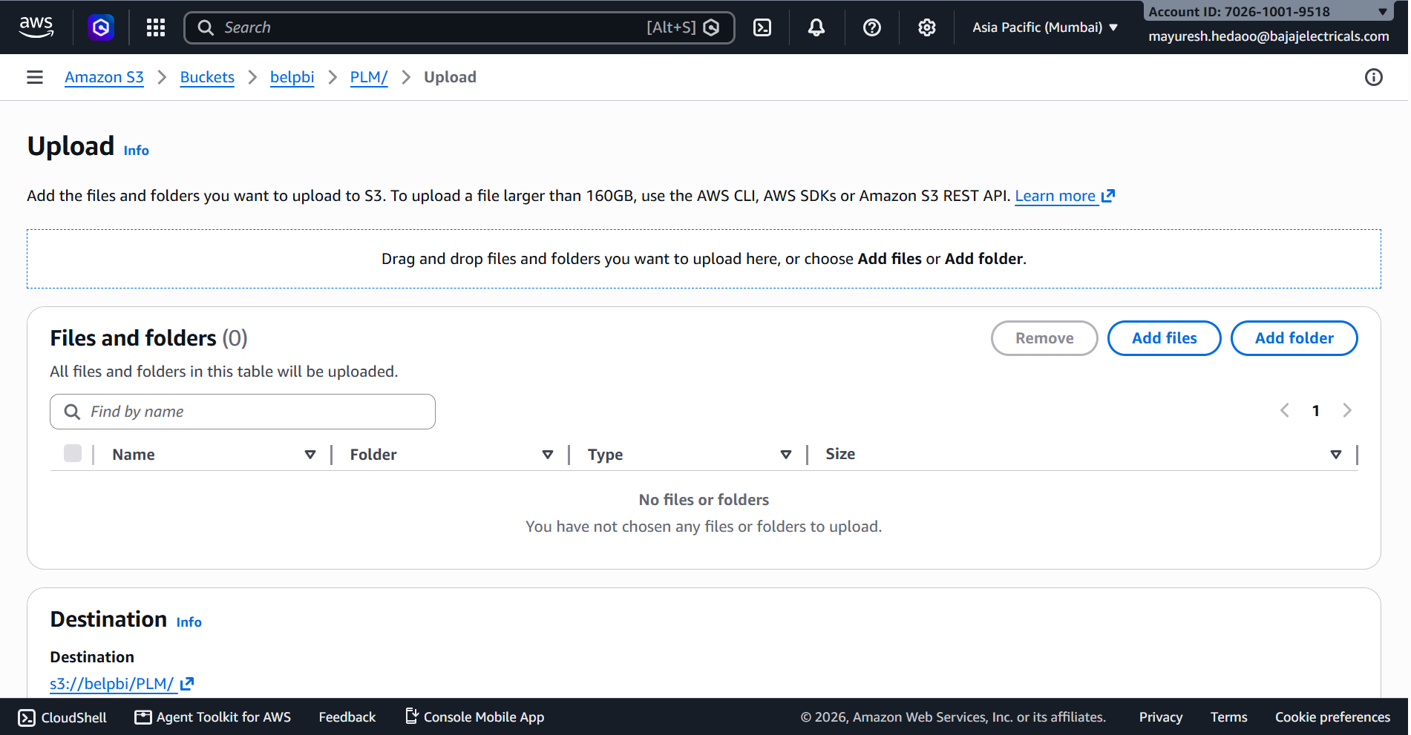

- Download below reports from the prod server as shows and rename that files with latest date as per doc - BEL AWS Reports.xlsx – Total 6 files as shown picture.

- Process To Generate and Download the Reports from prod server.

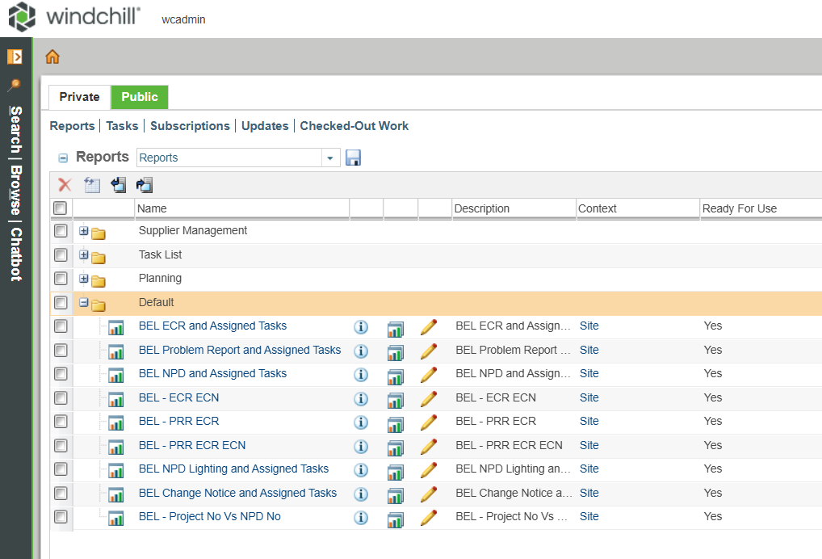

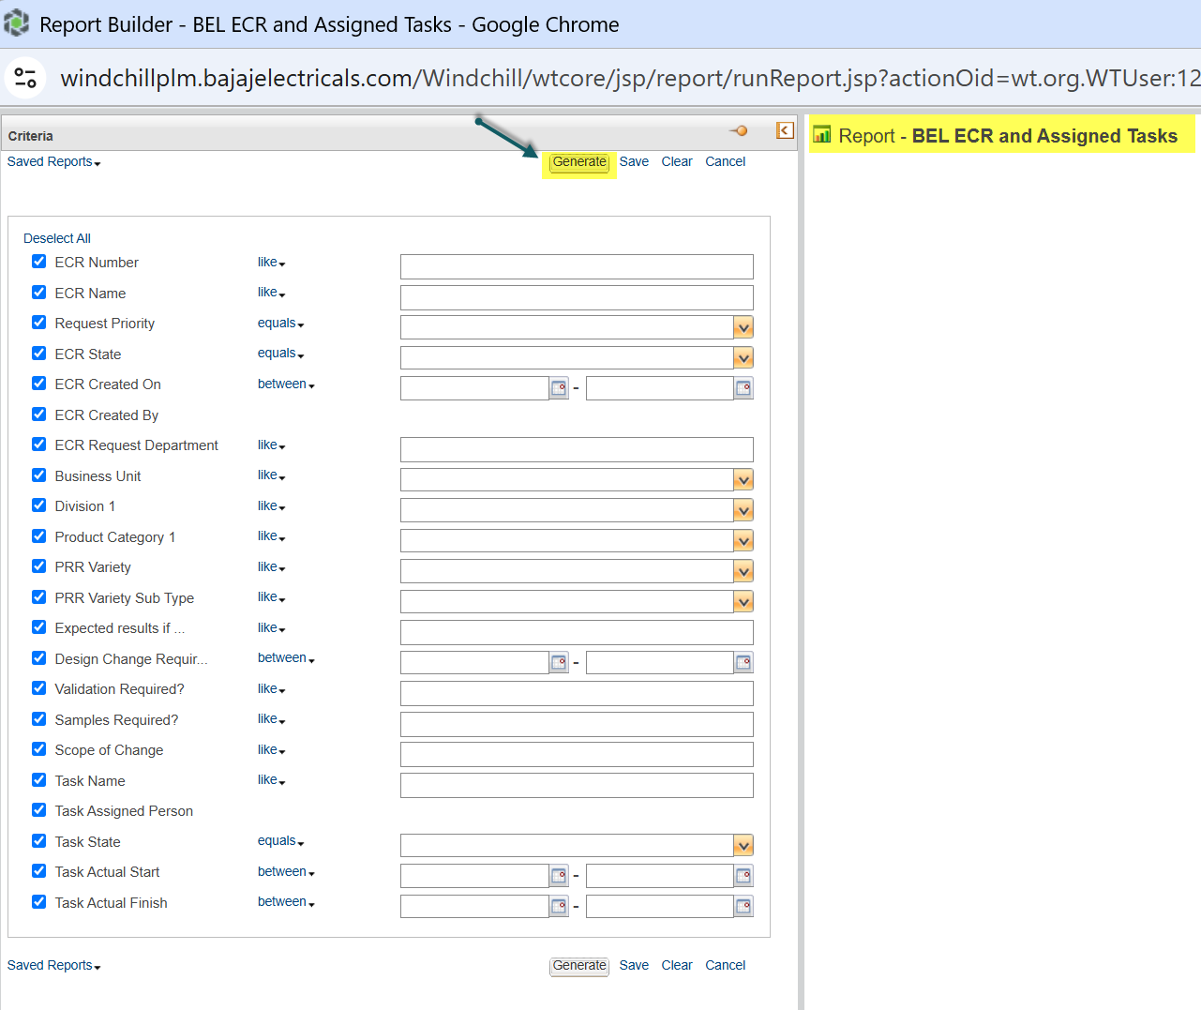
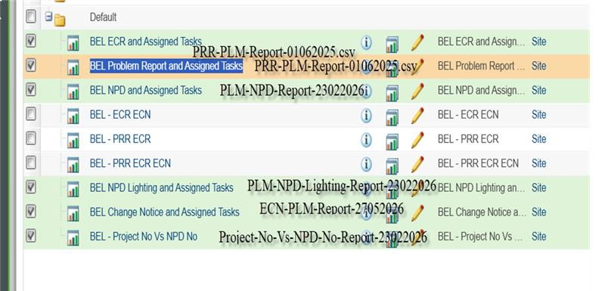

- Upload all files to AWS server.

